$$\boxed{MOMENT DISTRIBUTION METHOD}$$

To simplify the derivation, one assumes:
- Prismatic member (constant I)
- No member chord rotation ()
- No joint translation
- No support settlements

Step-by-Step Procedures
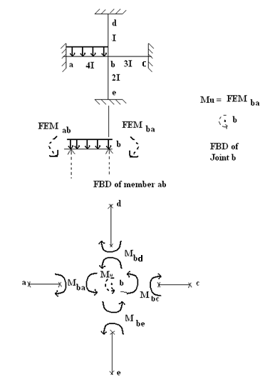

Step 1: Consider an unload structure and
joint b is also fixed (locked)

Step 2: When the uniform load acts on the structure,
${FEM}_{ab} and {FEM}_{ba}$are developed and can be computed.

Step 3: This $FEM$ will cause joint b to rotate CCW,
when joint b is unlocked $=>$ unbalanced moment

Step 4: When joint b rotates, certain moments are developed through out the length of all members meeting at joint b
$=>$ distributed moments

Step 5: Joint b will continue to rotate until sufficient distributed moments are developed at the “b” ends of these members to counter balance the effect of $M_{u}$.

Step 6: Simultaneously, end moments are developed at the far ends of these members
$=>$ carry over moments

Step 7: When equilibrium at joint b is established, the total end moments of various members will be the algebraic sum of the$FEM$ and the moments caused by the rotation of joint b.

$\sum{M_{at Joint b}}=0^{}= M_{u}+M_{ba} +M_{bc}+ M_{bd} + M_{be}$__________________(100)
Distributed moments
Using Slope Deflection Equation (SDE), with
$θ_{a}=0=θ_{c}= θ_{d}=θ_{e}$(Because fixed supports)
$Ψ_{ba}$= 0 = $Ψ_{bc}= Ψ_{bd}= Ψ_{be}$(Because no members’ chord rotations)
Zero, because it has already been accounted in the unbalanced moment $M_{u}$

One obtains:
$M_{ba}=2E\left(K_{ba}= \frac{I}{L}\right)\left[2θ_{b}+θ_{a}-\left(3Ψ_{ba}= \frac{∆}{L}\right)\right]+ {FEM}_{ba}$__________________(101)
$M_{ba}=4EK_{ba}θ_{b}$ zero
Similarly, $M_{bc}= 4EK_{bc}θ_{b}$ ____________________________________(102)
$$M_{bc}= 4EK_{bd}θ_{b}$$
$$M_{be}= 4EK_{bc}θ_{b}$$
Substituting Eq. (102) into Eq. (100): $4Eθ_{b}\left(\sum_{b}{K≡ }K_{ba}+K_{bc}+ K_{bd}+ K_{be}\right)+M_{u}=0$
Thus: $θ_{b}= \frac{-M_{u} }{4E(\sum{K})}$__________________________________________________(103)
Substituting Eq. (103) into Eq. (102):
$M_{ba}=4EK_{ba}*\frac{-M_{u} }{4E(\sum{K})}= -\left(DF_{ba}≡\frac{K_{ba}}{\sum{K}} \right)*M_{u}$
(104)
$$M_{bc}= -\left(DF_{bc}≡\frac{K_{bc}}{\sum{K}}\right)*M_{u}$$

How to compute carry-over-moment ($M_{ab}) from distribute moment \left(M_{ba}\right)?$
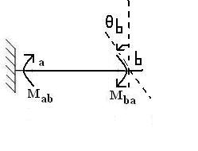
From Eq. (101), one has:
$M_{ab}≡Carry-over-moment= \frac{1}{2}M_{ba}$ (105)
$$M_{ba}=2E\left(K_{ba}\right)[2θ_{b}]$$

$$M_{ab}=2E\left(K_{ba}\right)[2θ_{a}+θ_{b}]$$
Zero

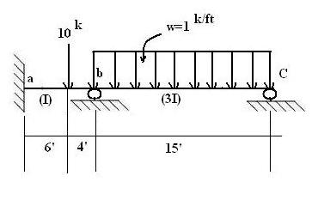
Example 1:

$K_{ba}= K_{ab}= \frac{I}{10}$ = 0.1 I
$K_{bc}= K_{cb}= \frac{3I}{15}$ = 0.2 I
${DF}_{ba}= \frac{K_{ba}}{\sum_{b}{K}}= \frac{0.1 I}{(0.1 I+ 0.2 I)}$ = $\frac{1}{3}$
${DF}_{ab}= \frac{0.1 I}{(\sum_{a}{K}= 0.1 I)}$ = $1$
${DF}_{bc}= \frac{K_{bc}}{\sum_{b}{K}}$ = $\frac{0.2 I}{0.3 I}$ = $\frac{2}{3}$ ${DF}_{cb}= \frac{0.2 I}{(\sum_{c}{K}= 0.2 I)}$ = $1$

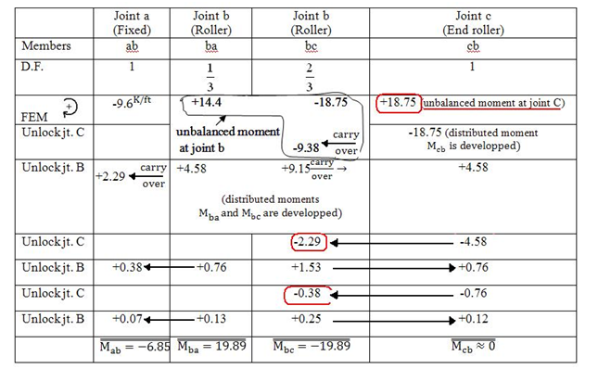

Reduced Member Stiffness with End Roller (or Pin) Support

- In Example1, convergence is rather slow because the (end) joint C is actually a “hinge end”, and continuously throws back a sizable carry-over-moments to joint b.

- Also, joint c should be unlocked and remains to be unlocked (as a hinge support), so that joint C will not be continuously received the carry-over-moment from joint b.

- Using SDE, with joint C is consider as a hinge support (not fixed support, hence $θ_{C}≠0)$one obtains:

$M_{cb}=2E\left(K_{Cb}\right)\left[2θ_{C}+θ_{b}\right]=0$ (Since moment at the hinge joint C is zero)
Hence:
$θ_{C}= - \frac{θ_{b}}{2}$

Also, $M_{bc}= 2E\left(K_{bc}\right)\left[2θ_{b}+θ_{C}\right]=2E\left(K_{bC}\right)\left[2θ_{b}- \frac{θ_{b}}{2}\right]=2E\left(K_{bC}\right)\left[\frac{3θ_{b}}{2}\right]$

Or:${ M}_{bC}= E\left(K_{bC}\right)\left[3θ_{b}\right]=4E\left(\frac{3}{4}K_{bC}\right)\left[θ_{b}\right]=4E\left(K_{bC}^{R} \right)[θ_{b}]$___________________(108)

Comparing Eq. (108) and Eq. (102), they look “very similar”. The only difference is that $K_{bc}$ (in Eq. 102) is replaced by the “reduced stiffness”

$K_{bC}^{R}≡\frac{3}{4}K_{bC}$________________________________________________________(109)

Example 2: Re-do Example 1 (but using reduced stiffness$K_{bc}^{R}$)

$K_{ba}= K_{ab}= \frac{I}{10}$ $→{DF}_{ba}=\frac{K_{ba}}{\sum_{b}{K}}=\frac{I}{10}*\frac{20}{5I}=0.4$

$K_{bc}^{R}= \left(\frac{3}{4}\right)K_{bc}=\left(\frac{3}{4}\right)\left(\frac{3I}{15}\right)= \frac{9I}{60}= \frac{3I}{20}$ $→{DF}_{bc}=\frac{K_{bc}^{R}}{\sum_{b}{K}}=\frac{3I}{20}*\frac{20}{5I}=0.6$

$$\sum_{b}{K=}K_{ba}+K_{bc}^{R}= \frac{I}{10}+\frac{3I}{20}= \frac{5I}{20}$$

 | Joint a  (Fixed) | Joint b  (roller) | Joint b  (roller) | Joint c  (end roller)
Member | ab | ba | bc | cb
DF | 1 | 0.4 | 0.6 | 1
FEM | $${-9.6}^{Kft}$$ | +14.4 | -18.75 | +18.75 (unbalanced moment at Joint C)
Unlock jt. C |  |  | -9.38$←\frac{carry}{over}$ | -18.75
Unlock jt.b | +2.75$←\frac{carry}{over}$ | +5.49 | +8.24 | N/A
 | $\overset{̿}{M_{ab}}= -6.85$ | $\overset{̿}{M_{ba}}=19.89$ | $\overset{̿}{M_{bc}}=-19.89$ | $$\overset{̿}{M_{cb} }=0$$

(Unbalanced moment at Joint b)

Example 3: (over hanging beam)

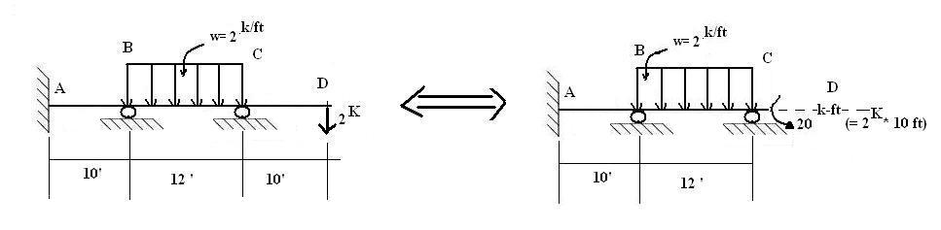
$${DF}_{BA}=\frac{K_{BA}}{\sum_{B}{K}}= \frac{I}{10}*\frac{80}{13I}=\frac{8}{13}$$

$${DF}_{BC}=\frac{K_{BC}^{R}}{\sum_{B}{K}}=(\frac{3}{4}*\frac{I}{12})*\frac{80}{13I}=\frac{5}{13}$$

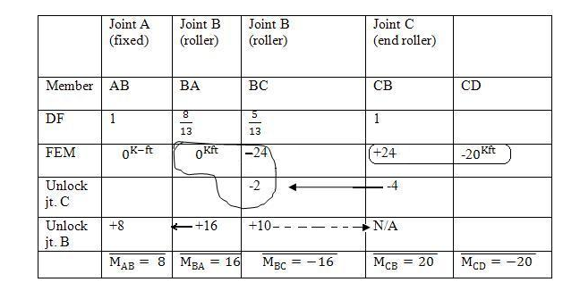
$\sum_{B}{K}= K_{BA}+K_{BC}^{R}=\left(\frac{I}{10}\right)+\left(\frac{3I}{48}= \frac{I}{16}\right)= \frac{13I}{80}$

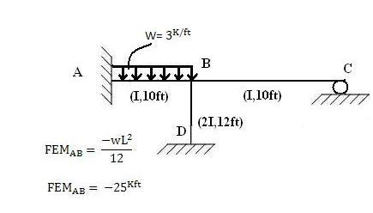
Example 4: (Frame Structure)

$${ K}_{BA}=\frac{I}{10} →{DF}_{BA}=\left(\frac{I}{10}\right)\left(\frac{120}{41 I}\right)= \frac{12}{41}$$

$$K_{BC}^{R}= \left(\frac{3}{4}\right)\left(\frac{I}{10}\right)=\frac{3I}{40}$$
$$→{DF}_{BC}=\left(\frac{3I}{40}\right)\left(\frac{120}{41 I}\right)=\frac{9}{41}$$

$$K_{BD}=\frac{2I}{12}=\frac{I}{6}$$
$$→{DF}_{BD}= =\frac{20}{41}$$

$$\sum_{B}{K}=\left(\frac{I}{10}+\frac{3I}{40}+\frac{I}{6}\right)= \frac{12I+9I+20I}{120}= \frac{41I}{120}$$

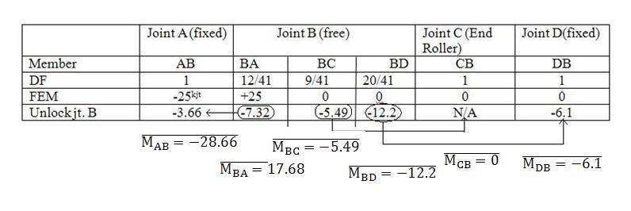

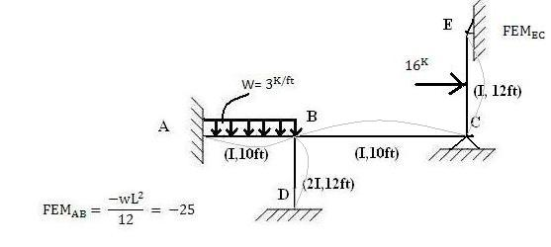
Example 5: (Frame Structure)

$K_{BA}=\frac{I}{10} →{DF}_{BA}=\frac{K_{BA}}{\sum{K_{B}}}= \frac{3}{11}$
$${ K}_{BD}=\frac{2I}{12}=\frac{I}{6} →{DF}_{BD}=\frac{K_{BD}}{\sum{K_{B}}}= \frac{5}{11}$$

$$K_{BC}=\frac{I}{10}{→DF}_{BC}= \frac{3}{11}$$

$$\sum{K_{B}}=K_{BA}+K_{BD}+K_{BC}= \frac{11I}{30}$$

$$K_{CB}=\frac{I}{10} {→DF}_{CB}=\left(\frac{I}{10}\right)\left(\frac{80}{13I}\right)= \frac{8}{13}$$

$$K_{CE}^{R}=\left(\frac{3}{4}\right)\left(\frac{I}{12}\right)=\frac{I}{16} { →DF}_{CE}= \frac{5}{13}$$

$$\sum{K_{C}}=K_{CB}+ K_{CE}^{R}= \frac{13I}{80}$$
(COM = Carry Over Moment)
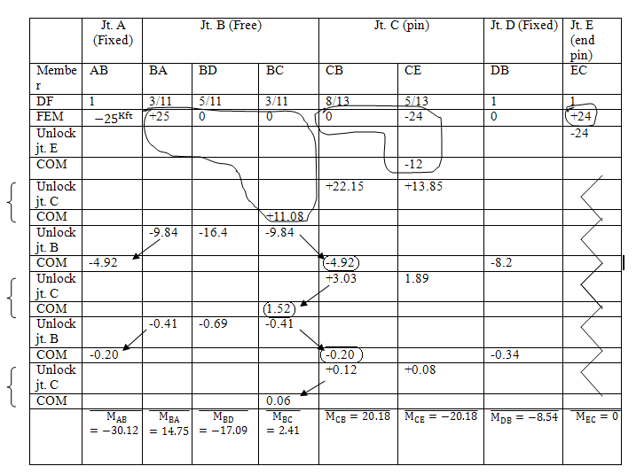
Moment Distribution (with Sideway)

Example 6:

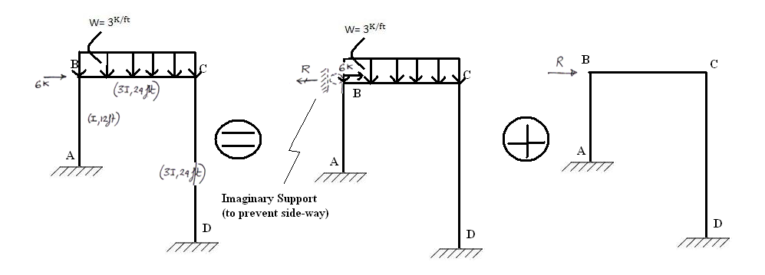
Case A: No side-way Case B: with side-way

[$FEM_{BC}= \frac{-wL^{2}}{12}= -144^{Kft}$
$FEM_{CB}=+144$]

$K_{BA}=\frac{I}{12} →{DF}_{BA}=\left(\frac{I}{12}\right)\left(\frac{24}{5I}\right)=0.4$
${ K}_{BC}=\frac{3I}{24}=\frac{I}{8} →{DF}_{BC} =0.6$
$$\sum{K_{B}}=\frac{I}{12}+\frac{I}{8}= \frac{5I}{24}$$

$K_{CB}=\frac{3I}{24} =\frac{I}{8}→{DF}_{CB}=\frac{K_{CB}}{\sum{K_{C}}}=0.5$
$K_{CD}=\frac{3I}{24} =\frac{I}{8}→{DF}_{CD}= = 0.5$
$$\sum{K_{C}}=\frac{I}{8}+\frac{I}{8}= \frac{I}{4}$$

Case A:

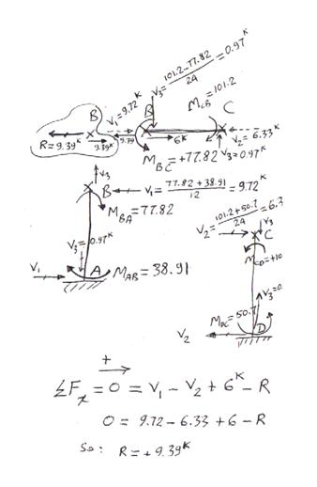
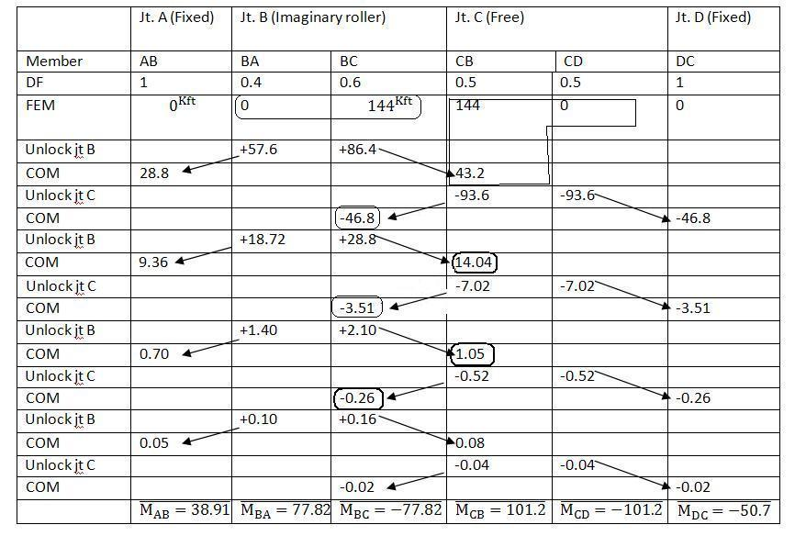

Case B: Fixed all joints, and applied side-way

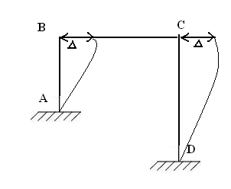
$M_{AB}=2E\left(\frac{I}{12}\right)\left[2θ_{A}+θ_{B}-3\left(Ψ_{AB}= \frac{+∆}{12}\right)\right]+ {FEM}_{AB}$

$$M_{AB}=\frac{-EI∆}{24}= M_{BA}$$

$M_{CD}=2E(\frac{3I}{24})\left[2θ_{C}+θ_{D}-3\left(Ψ_{CD}= \frac{+∆}{24}\right)\right]+ {FEM}_{CD}$

$$M_{CD}=\frac{-3EI∆}{96}= M_{DC}$$

Now, arbitrarily select EI$∆ ≡3840$

Hence, $M_{AB}= -160= M_{BA}≡{FEM}_{Due to settlement ∆}$
$M_{CD}= -120= M_{DC}≡{FEM}_{Due to settlement ∆}$
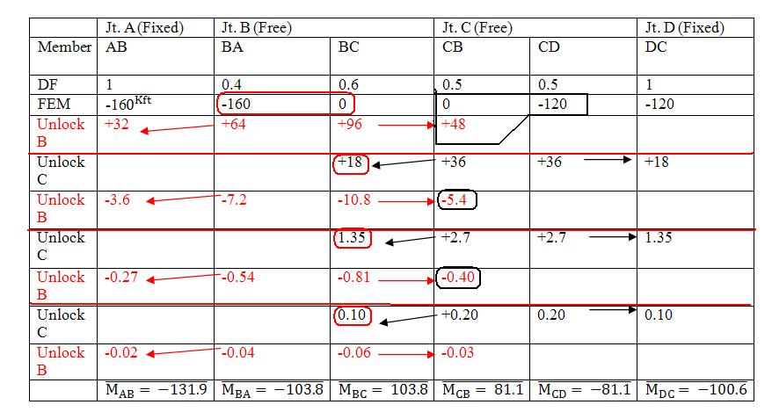

Determine the force P which causes
EI$∆ =3840$

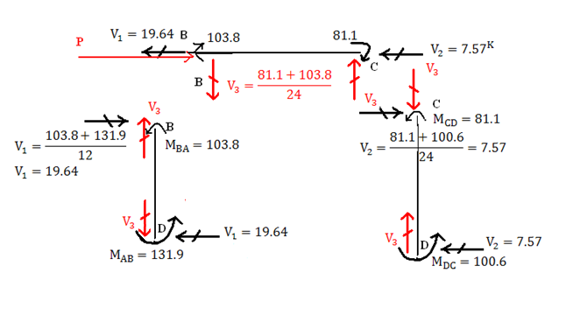
From Case B:

$(\sum{F_{x})_{Member BC}=0_{=}^{}P-V_{1}-V_{2}}$
$0=P-19.64-7.57$
Hence: $P=+27.21^{K}$
However, from case A, one only has $R=9.39^{K}$
Thus, case B results have to be scaled down by a ratio $Ratio=\frac{9.39^{K}}{27.21^{K}}=0.345$

New results for case B:
$$(M_{AB}^{*})_{case B}=(M_{AB})_{case B}*0.345=\left(-131.9\right)\left(0.345\right)=-45.52$$
$(M_{BA}^{*})_{case B}=\left(-103.8\right)\left(0.345\right)=-35.81$
$(M_{BC}^{*})_{case B}=\left(+103.8\right)\left(0.345\right)=+35.81$
$(M_{CB}^{*})_{case B}=\left(81.1\right)\left(0.345\right)=27.98$
$(M_{CD}^{*})_{case B}=\left(-81.1\right)\left(0.345\right)=-27.98$
$(M_{DC}^{*})_{case B}=\left(-100.6\right)\left(0.345\right)=-34.7$1

Superposition of Case A and Case B

The final end-moments of the original problem can be given as:
$M_{AB}=(M_{AB})_{case A}+(M_{AB}^{*})_{case B}=\left(38.91\right)+\left(-45.52\right)=-6.61^{K-ft}$
$${ M}_{BA}=(M_{BA})_{case A}+(M_{BA}^{*})_{case B}=\left(77.82\right)+\left(-35.81\right)=42$$
$${ M}_{BC}=(M_{BC})_{case A}+(M_{BC}^{*})_{case B} =\left(-77.82\right)+\left(+35.81\right)=-42$$
$M_{CB}= =\left(101.2\right)+\left(27.98\right)=129.1$
$M_{CD}= =\left(-101.2\right)+\left(-27.98\right)=-129.1$
$M_{DC}= =\left(-50.7\right)+\left(-34.71\right)=-85.4$

